Q1. #include<stdio.h>

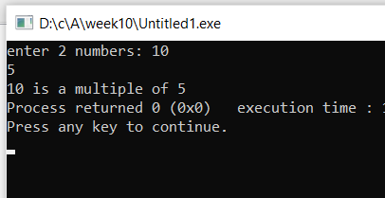void multiple(int x,int y)

{

if(x%y==0)

{

printf("%d is a multiple of %d",x,y);

}

else printf("Not a multiple");

}

int main()

{

int a,b;

printf("enter 2 numbers: ");

scanf("%d",&a);

scanf("%d",&b);

multiple(a,b);

}

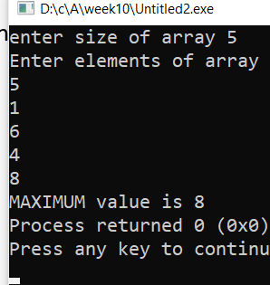Q2. #include<stdio.h>

void max(int n,int x[50])

{

int max;

max=x[0];

for(int i=1;i<n;i++)

{

if(x[i]>max)

max=x[i];

}

printf("MAXIMUM value is %d",max);

}

int main()

{

int a[50],n;

printf("enter size of array ");

scanf("%d",&n);

printf("Enter elements of array \n");

for(int i=0;i<n;i++)

{

scanf("%d",&a[i]);

}

max(n,a);

}

Q3. #include<stdio.h>

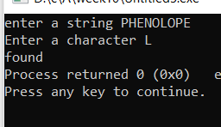void check(char a,char b[50])

{

int i=0,num=0;

while(b[i]!='\0')

{

if(b[i]==a)

{

num=0;

break;

}

else num=1;

i++;

}

if(num==0)

printf("found");

else printf(" Not found");

}

int main()

{

char a1,b1[50];

printf("enter a string ");

gets(b1);

printf("Enter a character ");

scanf("%c",&a1);

check(a1,b1);

}

Q4. #include<stdio.h>

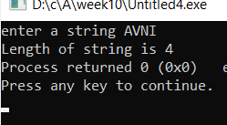int length(char b[50])

{

int i=0;

while(b[i]!='\0')

{

i++;

}

return i;

}

int main()

{

char a1,b1[50],a;

printf("enter a string ");

gets(b1);

a=length(b1);

printf("Length of string is %d",a);

}

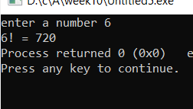Q5. #include<stdio.h>

int fact(int a)

{

int fact=1;

for(int i=1;i<=a;i++)

{

fact\*=i;

}

return fact;

}

int main()

{

int num;

printf("enter a number ");

scanf("%d",&num);

printf("%d! = %d",num,fact(num));

}

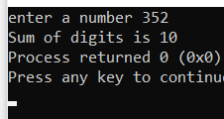Q6. #include<stdio.h>

int sum1=0,d; //Global variable

int sum(int a)

{

if(a){

d=a%10;

sum1=sum1+d;

sum(a/10);

}

else

return sum1;

return sum1;

}

int main()

{

int num;

printf("enter a number ");

scanf("%d",&num);

printf("Sum of digits is %d",sum(num));

}

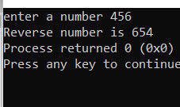Q7. #include<stdio.h>

int sum1=0,d; //Global variable

int rev(int a)

{

if(a)

{

d=a%10;

sum1=sum1\*10+d;

rev(a/10);

}

else

return sum1;

return sum1;

}

int main()

{

int num;

printf("enter a number ");

scanf("%d",&num);

printf("Reverse number is %d",rev(num));

}